TABLE OF CONTENTS

Demand full-kit backgroup 3
Data Extract & Translate 3
[DET01] MPS Raw Data 9
[DEC02]MPS PERIOD DATA 9
[DEC03]Priority List 9
[DET04]Material status shortage L1 9
[DET05] Material total period Balance 9
[DET06] Material status shortage L2 9
peration Steps 11

Trail Kitting With weekly demand
Usage:
Generate the full kit information and estimated.
Planner has the make-parts requirements (quantity and request date), if the materials in the BOM of the make-parts are all full-kits, the works order is easy to be created. But if some of the materials are not full-kits, planner should has a shortage list and let buyer provide the commit date and quantity of PO.
Buyer need to know the shortage, and prepare the call in plan with the shortage list. If the PO can cover the material required quantity, with the shortage items, Buyer will get the material items for call-in or gating handling.

Key Changes to the Data Model:
- MPS data.
- Shortage with period.
- Gating detail with period.

Items | Descriptions | Remark
MPS data | The Demand of top-level and make-parts in list with priority for full-kit simulation. The data sorted by request date, part id, product group
MPS period quantity | Top-level and make-parts with period, by week (3-40weeks) and by month (3-12monthes), include overdue quantity.
Material data | The material parts with requirements should be fetched by the MPS data and current BOM, with the BOM expanding, the usage per will be multiplied with the demand quantity.
Material period quantity | by week (3-40weeks) and by month (3-12monthes), include overdue quantity.

Data eXTRACT & trANSLATE [DET]

[DET01] MPS Raw data
Description:
This table holds the list of the MPS data.
The data will be required as the input options and planner full-kits analysis results:

Attribute Name | Key | Nulls | Oracle Format | Len | Comments
id | PK | No | NUMBER | 20 | MPS/MRP原生的planon, mserial; 如果是计划新加的，根据yyMMddhhmmss增加.
Part number |  | No | VARCHAR2 | 50 | Unique process identifier in shipment engine model.
Request data |  | No | DATETIME |  | MPS data, user can reschedule for simulating.
Quantity |  | No | DECIMAL | 2 | MPS data, user can update for simulating.
Product group |  | No | VARCHAR2 | 50 | Master data;
Priority |  | No | NUMBER | 5 | 根据时间, Prod-group,料号排序，或者根据用户提供的规则计算优先级; 用户可以通过拖拽动态修改优先级;
Original data is the list of the MPS data. Planner upload the planned data, with request date and quantity.
If the quantity different with original data, all the child parts in BOM should be re-calculated.

[DET02]MPS Period data
Description:
This table holds the list of make-parts with the period summary.

Attribute Name | Key | Nulls | Oracle Format | Len | Comments
Part id | PK | NO | VARCHAR2 | 50 | Make-parts
Month 1 |  | NO | NUMBER | 15 | 第一个月的需求, 同时cover掉这个月生成的active状态的工单;
Month 2 |  | NO | NUMBER | 15
Month n |  | NO | NUMBER | 15
Week 1 |  | NO | NUMBER | 15 | 第一周的需求，如果在周二0:00以后有新的工单，planned/MRP数量需要cover工单。
Week 2 |  | NO | NUMBER | 15
Week n |  | NO | NUMBER | 15

The data originated from BOM and MPS Raw data, with the what-if data upload the quantity of the MPS period data will be refreshed.
The quantity is the new demand quantity, with the formula:
Month1 net demand = gross period demand – WO quantity (after MRP)
If (WO quantity > gross period demand), the balance WO quantity will be used to cover the next period demands. (如果工单减去需求还多，则向后cover需求.)

OUTPUT:

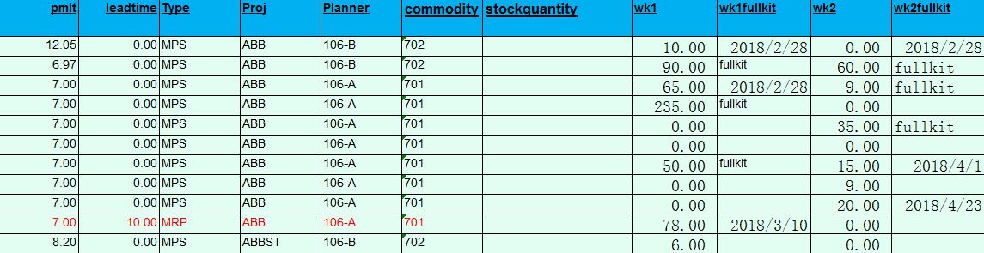
Output 文件路径: Request FullkitOutput.xlsx

Operation:
1. 系统自动每天早晨发一版trial Kitting report, 作为每天做shortage simulation和gating review的基础数据;
2. 提供系统界面，PMC根据这版数据修改数量重新上传实现demand material sizing和trial kitting;
3. 每次上传完MPS data, 需要比较一个period里面的数量，如果数量有变化，需要按照BOM和MRP的逻辑计算其下阶料的net demand.
4. 每个PMC需要有自己的独立版本，不能修改原数据和相互影响;
5. Demand

[DET03]Priority List
Description:
该数据作为计算trial kitting优先级的临时数据，period和在制件料号作为优先级的主键，需要在每次模拟时保存并作为追述参考；

Attribute Name | Key | Nulls | Oracle Format | Len | Comments
id | PK | No | NUMBER | 15 | If the planner upload demand, the id will be generated as unique id.
Part id |  | No | VARCHAR2 | 15 | Unique chain type identifier in shipment engine model.
Period id |  | No | VARCHAR2 | 30
Quantity |  | No | VARCHAR2 | 15
Priority number |  | No | NUMBER | 15

Gating: Open PO , commit 晚于request date; No PO, PO quantity not enough

[DET04]Material status shortage L1
Description:
The data is the calculation step for DET02, with the calculate process, the material shortage will be generated by period.
The material should be generated by expanding BOM with the top-level and make-part, the material and make-parts should be coupled with period id and quantity. The net request quantity should be covered by stock quantity and WO allocated quantity. Then the balance requirement quantity is the level 1 shortage.

Attribute Name | Key | Nulls | Oracle Format | Len | Comments
id | PK | No | NUMBER | 12 | Unique operation type identifier in shipment engine model.
Make part |  | No | VARCHAR2 | 50
Material part |  |  | VARCHAR2 | 50
Period id |  |  | VARCHAR2 | 20
Shortage quantity |  | No | DECIMAL | 2
Stock covered quantity | FK | Yes | DECIMAL | 4
Priority id | FK | No | NUMBER |  | Link to period temporary table

根据所选择的分析方式不同， 可以选择顺序shortage和平均shortage, 如果平均shortage, 缺料的数量将是最大的，只要共用料有一个缺料，所有的差异全部跑出来; 顺序shortage, 根据物料的先后顺序，得到优先级，这样有些料可以提前full-kit，或者部分full-kit，将产生不同的结果;
在修改make part数量或者reschedule时，两个指标需要重新计算并显示.

OUTPUT:

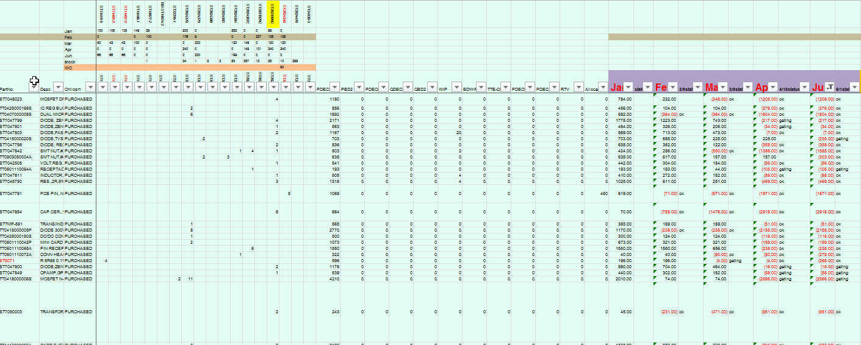

Output 文件路径: Request FullkitOutput.xlsx
Note:
1. 按照优先级计算原材料的period缺料数量;
2. 优先级计算规则[可配置可追溯]:
目前定义:
Priority (High --------------------------------------> Low)
专用料齐套，共用料齐套 → 专用料齐套, 共用料缺料的种类少 → 专用料不齐套, 共用料缺料种类多

Operation:
1. PMC在用户界面可视化操作, 可以通过拖拽改变优先级顺序，完成齐套分析;
2. 完成齐套分析，PMC可以点击保存，生成Shortage L2数据，即material gating数据, 并维护comments，用来识别是RUSH DEMAND的齐套分析，还是FOR Material Call-in的齐套分析;
3. 保存完毕的齐套结果需要有对应的齐套版本，不能删除和修改..
4. 所有进行齐套分析的原材料，需要过滤掉JIT&PACKAGE&CHEMICAL&TOOLING&LABLE

[DET05] Material total period Balance:
Description:
During material sizing and full-kit, the common material stock should be covered by requirement quantity, if the balance quantity not 0, it should be recorded for other make parts covered.
Attribute Name | Key | Nulls | Oracle Format | Len | Comments
id | PK | No | NUMBER | 6
Material |  | No | VARCHAR2 | 50
Period id |  | No | VARCHAR2 | 30
Balance quantity |  | No | DECIMAL | 2 | If it's the common part, the quantity is common net requirement covered by requires.

作为共用料，现有的库存需要被需求cover, 如果库存还有多，需要把临时结果保留，用于满足下一个在制件带来的需求；

[DET06] Material status shortage L2

Description:
With the fixed level 1 shortage data, the Open PO should be used to cover the net demand of Level 1.
Open PO used to cover contain the data of open PO and VMI PO, the data should be correct and released by buyers. If the net requirement cannot be covered with open PO, or the open PO cannot be scheduled in to cover the required, the PO will be gating PO. No PO means the part is gating.

Gating List header
Attribute Name | Key | Nulls | Oracle Format | Len | Comments
id | PK | No | NUMBER | 6
Material |  | No | VARCHAR2 | 50
Period id |  | No | VARCHAR2 | 30
Balance quantity |  | No | DECIMAL | 2
Open PO quantity |  | No | DECIMAL | 2

Gating List detail
Attribute Name | Key | Nulls | Oracle Format | Len | Comments
Gating id | FK | No | NUMBER | 6
Material |  | No | VARCHAR2 | 50
Period id |  | No | VARCHAR2 | 30
Open Order id |  | No | VARCHAR2 | 2
Open Order item |  | No | NUMBER | 2
Open PO quantity |  | No | DECIMAL | 2
PO balance quantity |  | No | DECIMAL | 2
Is gating |  |  | bool

OUTPUT:
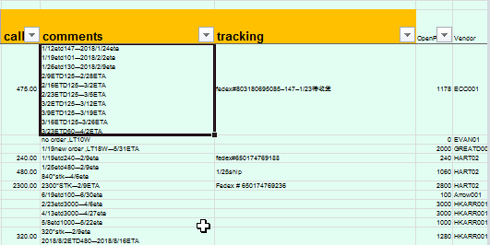
<报表模板同DET04 Shortage simulation L1的数据>
Output 文件路径: Request FullkitOutput.xlsx

Note:
1) OPO 的数量按照period进行累加计算，计算规则同库存计算，如果当前OPO能满足,则依次向后cover需求，同MRP的Project stock.
2) gating PO 按照period而不是全部显示 (待确认)
3) 采购需要报表能够抓出所有未commit的gating PO和未创建订单的gating part.
4) by week 计算gating, 13 week (3,40week), 正常采购需要看3个月的gating.
5) 所有Open PO和gating parts都要计算ETA, 分类(4种):
1) 有opo commit的, 但交期无法满足;
2) 有opo 未commit的,以PO Approve的时间加Leadtime+DTS作为交期, 进行比较完后确认是不是gating;
3) 没有opo，以当天时间加leadtime+dts, 计算出来的结果确认是不是为gating. 如果Period是Month，TT Calendar的第一周的周五。
4) JIT&Package&化学品全部忽略

Remark: What's Gating
三天或者一个礼拜, 供应商回复的交期计算出来的ETA-request <= 3 days(不同period 类型gating计算有待确认)

Operation:
1) 对于Consignment和VMI的订单，需要供应商使用Vendor Portal确认至少3周的交期。
VMI/Consign
Column
P/N
Supplier Stock Qty/On way
Rec Date
Rec qty
采购按照格式集中上传VMI/Consign的gating；

2) 采购需要在每周完成系统提供的Gating review, 对于commit date的修改，需要在界面上点击重新计算并生成full-kit 结果 系统要先产生一份总的gating, 根据gating类型，如果有OPO, 生成一份建议Pull-in的清单，给采购参考. 周二一份总的gating,
3) 根据计划模拟的结果，自动产生一份gating list对应的订单，

operation step
系统MRP静态数据的分析:
Remark: 半成品(除了两颗料以外)没有bulking和MOQ绑定, 优先级可以从成品直接迭代.

MRP
取得物料主档相关信息,库存和订单

每天的在制件需求数量减去open WO, 如果工单complete, 需求减去工单对应的数量。
计算每个在制件的优先级. 半成品共用的情况半成品优先级与其toplevel一致
取得在制件需求清单
计算原材料的需求/full-kit和gating.

输出结果，记录版本信息

用户自定义输入的WHATIF 分析:
Remark:
第一步: 计划根据客户提供的demand(销售需求), 根据当前的BOM在系统中生成半成品需求数量(需要扣减半成品的库存和工单)
第二步: 系统根据输入的物料计算优先级，并提供用户界面，可以得到优先级，或者调整优先级;
第三步: 执行Trail Kitting分析, 得到shortage simulation / full-kit status / gating List.

取得物料主档相关信息,库存和订单
输入客户提供的需求/ top-level, 数量, 交期

需求数量减去open WO, 如果工单complete, 需求减去工单对应的数量。
计算每个在制件的优先级. 半成品共用的情况半成品优先级与其top-level一致
计算所有半成品的需求, 并迭代优先级;
计算原材料的需求/full-kit和gating.

输出结果，记录版本信息

Output Template
- 输出明细 – 基于成品物料 (半成品是否显示)
栏位名 | 描述
成品料号
订单编号
订单数量
订单交期回复
订单或需求数量汇总
计划余量
日期1 | WK01(Month01)的最后一天
日期2 | WK02(Month02)的最后一天
日期3 | WK03(Month03)的最后一天
日期4 | WK04(Month04)的最后一天
日期n | WKn(Monthn)的最后一天

- 输出明细 – 需求单明细 (半成品是否显示)
栏位名 | 描述
成品料号
订单编号
订单数量
订单交期

- 采购gating list
栏位名 | 描述
成品料号
订单编号
订单数量
订单交期

